Ethan Allen Spotted Sofa

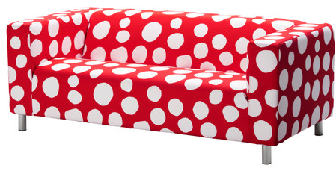

|  |
| --- |
| **DESCRIPTION** |
| Spotted Sofa produced by Ethan Allen Co, presents a white spots but red comfortable sofa. The single cushion acts like a long split less seat with extra long legs on bottom make it easy to clean under the sofa. Air tight and spring form works together to maintain sofa to keep the shape together and double coding lifts the sofa. |

|  |  |  |
| --- | --- | --- |
| **Price** | **3600$** | |
| **Dimensions** | **H** x **W** x **L** | **35in x 32in x 68in** |
| **Features** | **Spotted features gives a great look for the house interior designs which means it will achieve a great target as well as a great look and bends with the surroundings.** | |
| **Finished** | **Spot silk feeling** | |
| **Available in** | **Red with white spots and Blue with green spots** | |